# GPS Tracker 1.

Este es un rastreador GPS que busqué en Alibaba, el precio de este mismo es variable, recordar que estos sitios se manejan a través de la negociación, la cantidad mínima de compra es de 50 unidades, me parece que podría ser apto para trabajadores si es que se logra acoplar a la ropa, o bien mediante otra forma de llevarlo puesto, además no pesa casi nada (70g) y es pequeñísimo (7,7cm x 4,7cm).

Acá dejo el enlace al producto y sus especificaciones.

<http://www.alibaba.com/product-detail/Meitrack-GPS-Tracker-with-Free-Tracking_452361195.html?spm=a2700.7724838.30.1.6Q75wm>

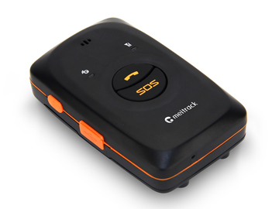

|  |
| --- |
| **SPECIFICATIONS** |

|  |  |  |  |  |  |  |  |
| --- | --- | --- | --- | --- | --- | --- | --- |
|  | Dimension |  | 77 mm x 47 mm x 20 mm |  | Weight |  | 70g |
|  | Charging voltage |  | Micro USB charging port, DC 4.2V-5.5V/400 mA |  | Power consumption |  | 60 mA standby current and 5 mA deep sleep |
|  | Standby battery |  | 1100 mAh/3.7 V rechargeable and replaceable lithium-ion battery(Nokia BL-5C compatible) |  | Operating temperature |  | -20°C to 55°C |
|  | Humidity |  | 5%–95% |  | Working hour |  | 160 hours in power-saving mode and 14 hours in normal mode |
|  | LED indicator |  | 2 indicators showing power, GSM, and GPS status |  | Button/Switch |  | 5 buttons/switches |
|  | Microphone/Loudspeaker |  | Internal microphone and loudspeaker |  | Memory |  | 8 MB byte (130,000 GPS Logs, 8,000 GPRS caches, and 256 SMS caches) |
|  | Sensor |  | 3D acceleration sensor |  | GSM frequency band |  | GSM 850/900/1800/1900 MHz |
|  | Positioning accuracy |  | 10m |  |  |  |  |

|  |
| --- |
| **ACCESSORIES** |

|  |  |  |  |  |  |  |  |  |  |  |  |
| --- | --- | --- | --- | --- | --- | --- | --- | --- | --- | --- | --- |
|  | MT90 Tracker |  | A battery |  | USB cable |  | Travel adapter (charger) |  | Screwdriver |  | Lanyard |
| CD and printed Meitrack MT90 user guide | | | | | | | | | | |

|  |
| --- |
| **CERTIFICATES** |

Meitrack GPS Tracker with Free Tracking Platform

# GPS Tracker 2.

Este es otro rastreador GPS que busqué en Alibaba, tiene un tamaño de (6,1cm x 4,9cm), y un peso de 173g aprox.

Además viene con un cinturón, y me pareció novedosa la forma en que lo equipan.

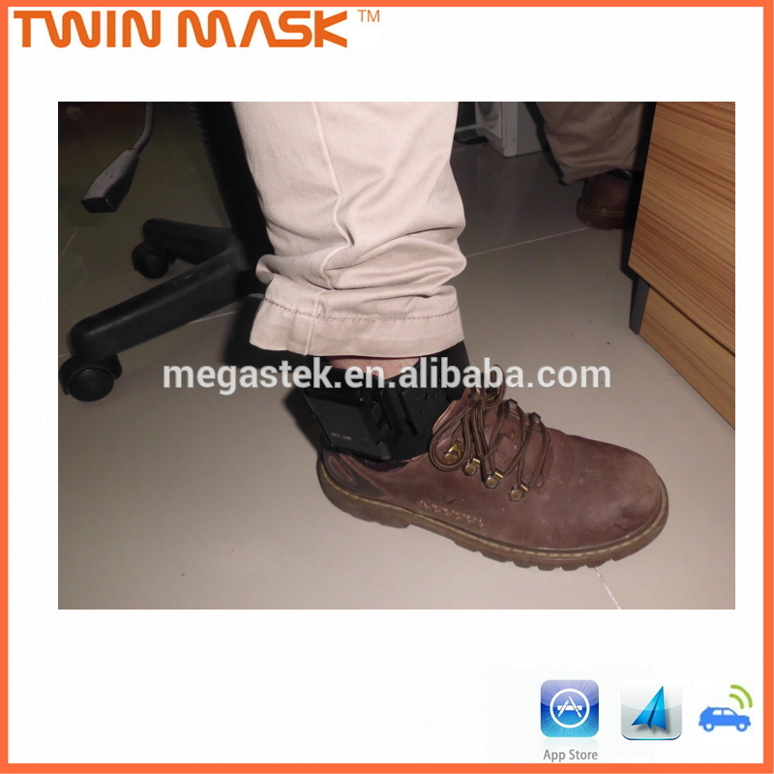

Dejo el enlace al producto y sus especificaciones.

http://www.alibaba.com/product-detail/gps-personal-tracker-with-tamper-proof_60365073676.html?spm=a2700.7724838.30.283.GvO9Ta